3D Printing Competition 2025
Submission Form
Full Name* | Primary contact person name
Email | Primary contact email for communication related to competition
Contact Number | Primary contact number for communication related to competition
Age (as of 2025)
Competition Theme | ☐ Singapore: Past, Present & Future (T1)  OR  ☐ Singapore as a Green and Sustainable Nation (T2)
Project Title | Each team must submit a unique Project Title that best represents your 3D printing creation and its purpose
Team Name | Each team is required to indicate with a unique Team Name that reflects your creativity and identity
Full Name* (Team member#2) | Team member name
Age (as of 2025)
Full Name* (Team member#3) | Team member name
Age (as of 2025)
Full Name* (Team member#4) | Team member name
Age (as of 2025)
Contact Email (alternative)
Contact Number (alternative)

Submission Date | Between 21 October to 22 October 2025 from 9.30am to 4.00pm
Submission Date | You are required to submit the printed parts in person on any of the dates mentioned above.
Submission Address | Nanyang Technological University  Singapore Centre for 3D Printing  Block N3.1-B2c-03  65 Nanyang Drive  Singapore 637460
*Name provided will be printed on the certificate. Hence, we appreciate if you could type in the details instead of handwritten to avoid any discrepancy.
Brief description of your design in less than 300 words.
(Use Arial font size 12)

As a team, share with us your journey and learning outcome(s) - 300 words
(Use Arial font size 12)

Images of the 3D printed part.
You may extend this box depending on the image size

Feedback & Survey:
Tell us your journey! 📲 Scan the QR code and share how this competition sparked creativity and inter-generational learning.
We request that every participant complete this survey.
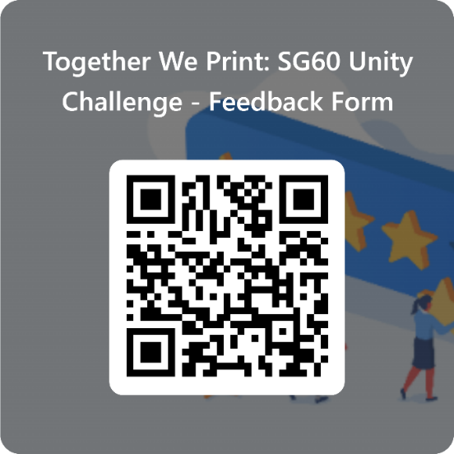
By entering this competition, we declare that
- This entry is our original work.
- This design including picture, icon, symbol within, shall not in any way infringe any third party’s right, including but not limited to copyright, logos, trademark, or other proprietary rights.
- We understand that should our entry be found in breach of any of the above 2 points, it will be disqualified automatically.
- We understand that if our submission is received after 4.00pm on 22 October 2025, the organiser reserve the right to reject the submission.
- We agree that the organiser will retain ownership of all entries and the organiser reserves the right to use and alter it in any manner deemed fit, without payment of any fee.
- By submitting this for, we hereby acknowledge that we have read and understood NTU Privacy Statement (“Statement”), and we consent that Nanyang Technological University can collect, use and disclose all the personal data provided by you in accordance with the Statement and/or Personal Data Protection Act.

Signature: ___________________________________________
Name:______________________________________________
Date:_______________________________________________

For Official Use Only:
Printed part submitted in good condition  YES ☐ NO ☐ | REMARKS:

Entry Number | ☐ T1-PPF/  ☐ T2-GSN/
Date
Name

Acknowledgement (For Official Use Only)

Entry Number | ☐ T1-PPF/  ☐ T2-GSN/
Date

